WELCOME

1

About you

Today’s Date: ____/____/____ File #:_____

**Patient Name:**______________________________________

LAST FIRST MI

Preferred Name:________________  ** Male  Female**

Birthdate:_____/_____/____ Age:____

Mailing Address:_____________________________________

__________________________________________________

CITY STATE ZIP

Home Phone #:_____________________________________

Work Phone #:________________ Other:________________

Email Address:______________________________________

Referred By:________________________________________

**Employer:**_______________________ How Long?_________

Employer’s Address:_________________________________

__________________________________________________

CITY STATE ZIP

Occupation:________________________________________

Status: Minor  Single Married Separated Widowed

Spouse’s Name:_____________________________________

Do you have children?  Yes  No How many?________

Chiropractic care is the practice of using spinal alignment to alleviate a wide variety of physical ailments, including neck pain, chronic back pain, headaches, disc problems, arm pain, leg pain and more. This is accomplished by adjusting the position of the spinal column to its proper shape, providing a non-invasive solution for pain relief.

​

**Our Mission**

Our mission at Cicero Chiropractic is to serve our community by giving premier chiropractic care. We strive to work together with our patients to provide the education and care necessary to restore and maintain optimum health

2

Account info

**Person ultimately responsible for account**

Name:­________________________________________

Relationship:___________________________________

Billing Address:_________________________________

_____________________________________________

CITY STATE ZIP

Insured’s SS #:_________________________________

______ I hereby authorize assignment of my insurance

**Initials** rights and benefits directly to the provider for services rendered. I fully understand I am solely responsible for any balance not paid by my insurance company.

3

In case of emergency

Who should we contact?____________________

Relation?_­­­­­­­­­­­­­­­­________________________________

Home Phone #:____________________________

Work Phone #:____________________________

Who is your Medical Dr?____________________

M.D.’s Phone #:___________________________

Please continue on the back side

Health history

**Are you taking any of the following medications?** **:**  Nerve pills  Pain killers (including aspirin)

Muscle Relaxers  Blood Thinners  Tranquilizers  Insulin  Other(s) __________________________



**Do you have or have you had any of the following diseases, medical conditions or procedures?**

**Y/N** Heart Attack/ Stroke **Y/N** Heart Surg./Pacemaker **Y/N** Heart Murmur  **Y/N** Congenital Heart Defect **Y/N** Mitral Valve Prolapse

**Y/N** Artificial valves **Y/N** Alcohol/Drug Abuse  **Y/N** Venereal Disease **Y/N** Hepatitis  **Y/N** HIV +/AIDS/ ARC

**Y/N** Shingles **Y/N** Cancer  **Y/N** Freq. Neck Pain  **Y/N** Glaucoma  **Y/N** Anemia/Diabetes

**Y/N** HI/Low Blood Pressure **Y/N** Psychiatric Problems  **Y/N** Rheumatic Fever  **Y/N** Severe/Freq. Headaches  **Y/N** Kidney Problems

**Y/N** Ulcers/Colitis **Y/N** Fainting/seizures/epilepsy **Y/N** Sinus Problems  **Y/N** Emphysema/Asthma  **Y/N** Tuberculosis

**Y/N** Difficulty Breathing **Y/N** Chemotherapy  **Y/N** Low back issues  **Y/N** Artificial bones/joints/implants  **Y/N** Arthritis

Please list any surgeries with dates and/or any other serious medical conditions(s) not listed above:____________

____________________________________________________________________________________________

List any past serious accidents with dates:­­­­­­­­­­­__________________________________________________________

Please list anything that you may be allergic to:______________________________________________________

Family Health history:__________________________________________________________________________

Do you take Supplements or vitamins?  Yes  No Do you exercise?  No  Yes_____hours per week

Do you smoke?  No  Yes How much________ How Long?_____________

Are you wearing:  Shoe lifts  Inner soles  Arch Supports Are you dieting  No  Yes Since___/___/____

**For Women:** Are you taking Birth Control?  Yes  No

Are you nursing?  Yes  No Are you Pregnant?  No  Yes If so, How many weeks______________

* Our policy requires payment in full for all services rendered at the time of visit, unless other arrangements have been made with the business manager. If account is not paind within 90 days of the date of service and no financial arrangements have been made, you will be responsible for legal fees, collection agency fees, interest charges and any other expenses incurred in colleting your account.
* I authorize the staff to perform any necessary services needed during diagnosis and treatment. I also authorize the provider to release any information required to process insuarance claims
* I understand the above information and guarantee this form was completed correctly to the best of my knowledge and understand it is my responsibility to inform this office of any changes to the information I have provided.

Signature:_____________________________________Date:_____/____/____  Parent/Guardian  Spouse

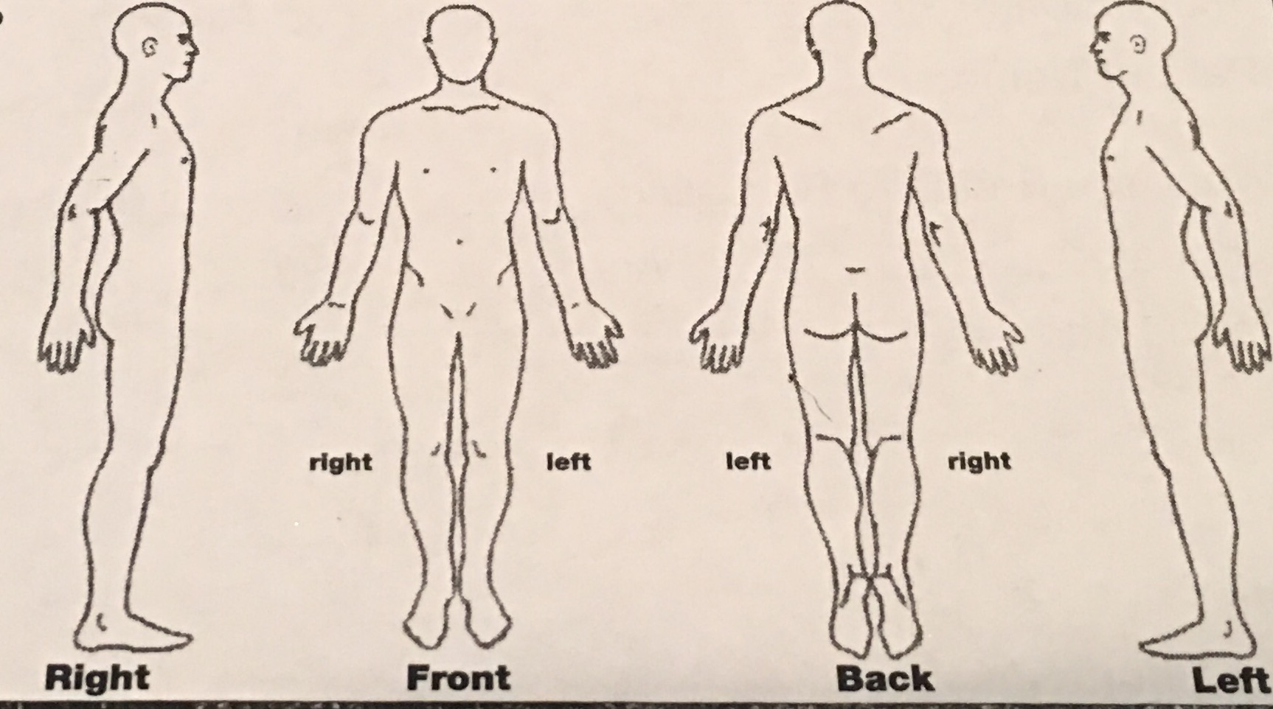

Reason for today’s visit **:**  Emergency  New Injury  Old Injury  Chronic Pain  Wellness

Are you in pain:  Yes  No Rate your pain with the following scale: discomfort **1 2 3 4 5 6 7 8 9 10** intense

Did your injury occur during:  Work  Sports/play  Auto Accident  Routine/Household Activity

When did your condition/accident occur? _____/_____/_____ Where did your injury occur?_______________

Please explain what happened:_________________________________________________________________

Is your condition getting worse?  Yes  No Constant  Comes and goes

Is your condition interfering with your:  Work  Sleep or  Daily routine? If so, how:__________________

Has this or something similar happened in the past?

Yes  No Explain:________________________

_______________________________________

**Using the adjacent body charts, please circle all**

**affected areas.**

Have you been treated by a Chiropractor or

Medical Physician for this condition?  Yes  No

If so, where?____________________________________

Clinic or Dr.’s Name:______________________________

Clinic Phone #:___________________________________